**Load Model**

Practice of Artificial Intelegence

Name : 劉泰佑

Id : C100E030

Sorry sir I use VSCode, so the method might be a little different. But it works perfectly

1. Save Model into “Model” folder as cat_dog.h5 (include in the train program)

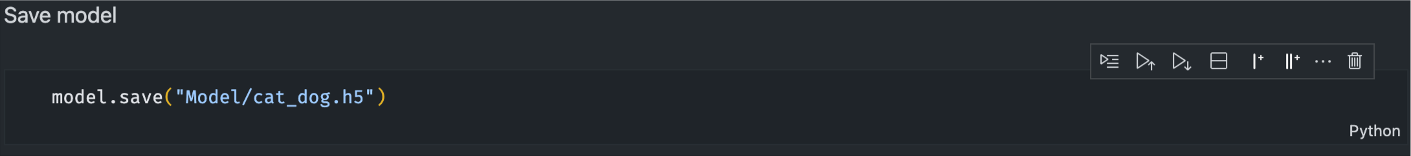

1. Load Model into program

1. Model Summary

